## Executive summary

Kiwi Minerals Limited (KML) is an underground mineral exploration company in New Zealand. The government has contracted them to digitally map the gold and silver resources in the Hawkes Bay region of the Mahia Peninsula, mainly owned by local iwi. KML has a budget of $5 million and 12 months to complete the project. This is a significant project for KML. To meet project expectations and deadlines, they need to hire a Project Director (PD) for the new project office in Napier.

This report aims to inform KML’s Board of Directors about three focus areas crucial to KML’s success, starting with the capabilities KML should seek in their new PD to ensure successful project management and delivery. KML also needs to consider Māori cultural values and operating principles, as they play a massive role in how explorations are conducted on iwi-owned land. Apart from this, KML’s corporate social responsibility (CSR) initiatives must embed principles of sustainable activities to minimise any social or environmental impact that may be caused to the iwi or their land, thereby increasing trust and opportunities for future partnerships with all KML stakeholders.

To accurately inform KML’s Board of Directors, frameworks, insights and recommendations were gathered from trusted government, mineral exploration, Māori, business, job descriptions and theoretical knowledge bases like the New South Wales public sector capability framework (NSWPSC, Government, n.d.), Careerforce, (2017), New Zealand Petroleum & Minerals (NZPAM, n.d.), Te Arawhiti (n.d.), and the Prospectors & Developers Association of Canada (PDAC, n.d.) toolkit, which are further elaborated on in the report.

Table of Contents

Executive summary 2

1. Introduction 3

2. Capabilities of the Project Director 4

2.1. Capability 1: Personal attributes - Act with Integrity 5

2.2. Capability 2: Business enablers: Project Management (PM) 8

3. Maori values as an integral part of KML’s project success 10

3.1 Māori Value 1: Kaitiakitanga 11

3.2 Māori Value 2: Whakarite mana 12

3.3 Māori Value 3: Whanaungatanga 13

4. CSR issues KML should consider in their risk management plans 14

4.1 CSR issue 1: Stakeholder engagement 16

CSR Issue 2: Safety 18

5. Conclusions and Recommendations 19

6. References 19

7. Appendix 25

Table of Figures

Figure 1: NSW Public Sector Capability Framework5 …………………………………………………………………………………………4

Figure 2: Capability: Act with integrity ………………………………………………………………………………………………………………6

Figure 3: Capability: Project Management ………………………………………………………………………………………………………..8

Figure 4: ISO 26000:2010 ………………………………………………………………………………………………………………………………..14

Figure 5: CSR: Stakeholder engagement ………………………………………………………………………………………………………….16

Figure 6: Boulder sampling using a hammer ……………………………………………………………………………………………………24

Figure 7: Drilling survey machinery for gold exploration …………………………………………………………………………………25

# KML Mineral Exploration Project in Hawkes Bay, New Zealand

## 1. Introduction

The Government of New Zealand recognises that the mineral industry is vital to the economy’s growth. It creates highly skilled and compensated labour opportunities and contributes to the country’s GDP (NZPAM, 2021). Hence this report aims to inform KML’s Board of Directors on the three focus areas which will aid New Zealand’s government with valuable results from the mineral exploration project in Hawkes Bay.

The report includes a critical review of three focus areas linked to KML’s project needs, considering their multiple stakeholders and the risks they need to mitigate. Findings are presented with recommendations and implications, starting with KML’s PD capabilities: acting with integrity and project management to enable efficient project operations. The report then reviews three Māori values: Whanaungatanga, Whakarite mana, and Kaitiakitanga and how they align with Māori decision-making. Thirdly, risk mitigation plans are presented for two CSR issues: stakeholder engagement and employee safety, to minimise room for disputes and ensure safe operations. The report ends with a summary, conclusion, references and an index of research findings.

## 2. Capabilities of the Project Director

Sykes & Trench (2017) found that leadership was crucial for a mineral exploration project’s success. For KML, leaders need to hire a PD with experience overlooking similar mineral exploration and digital mapping contracts successfully delivered in their previous roles. A PD for this project will need to keep the budget, local mineral exploration regulations, stakeholder relations, and environmental impact in mind according to PD job descriptions (JDs) listed by Worley (2023) and Jobs4Mining (2016). The JDs also point to the PD needing managerial skills for change, risk, quality, and time management, which are considered foundational to driving a project’s success. Hence, the capability framework used to select KML’s PD capabilities was acquired from the New South Wales Public Sector Capability Framework (NSWPSC, 2021). This framework includes 20 core capabilities under five groups that align with the knowledge, skills and abilities required for the PD role, as defined below in figure 1.

*Figure 1:* NSW Public Sector Capability Framework (Source: NSWPSC, 2021)

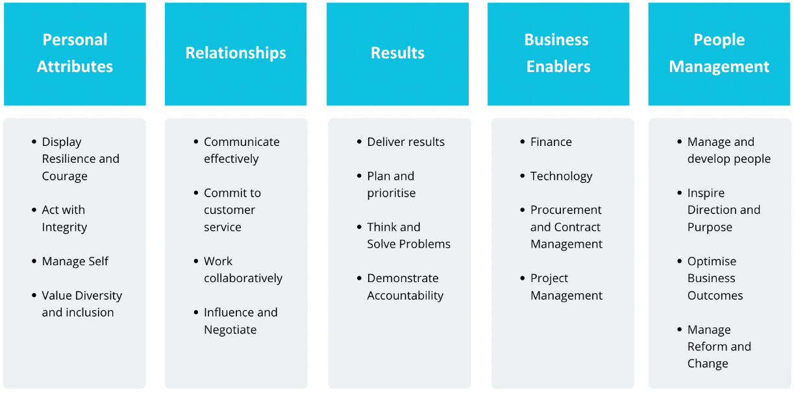

After examining the PD JDs mentioned above and correlating project management findings, two capabilities were identified for KML’s PD: acting with integrity and project management. They were chosen as critical capabilities for the new PD after considering factors like mineral exploration laws, the multiple stakeholders involved in the project lifecycle, budget, timelines, reporting and risk management variables.

### 2.1. Capability 1: Personal attributes - Act with Integrity

According to AuditNZ (n.d.), integrity means not just complying with the law but also being honest and having ethical principles. It is about always doing the right thing. In Māori culture, integrity is represented by concepts like tika, poni, and aroha, which entail doing the right thing with love. Maintaining integrity is crucial in the mineral exploration industry, as demonstrated by regulations and practices of governing bodies like New Zealand Petroleum & Minerals (NZPAM, n.d.), South Australian Energy and Mining governance (2023) and companies like RSC Geological Consultants (n.d.). They have codes of conduct that guide interactions with landowners and stakeholders, emphasising the importance of ethical principles in their decision-making processes.

The NSWPSC framework’s integrity capability (2021) in figure 2 aligns with NZPAM, RSC, and SA’s integrity guidelines, showing the need for KML to hire a PD with this capability. This allows KML to be represented ethically and compliantly among their stakeholders and allows the PD to model a code of ethical conduct for the project team. It also enables KML’s CSR strategy, thereby guiding stakeholder engagement and keeping KML’s employees safe and supported in the process.

*Figure 2:* Capability - Act with Integrity (Source: NSWPSC, 2021)

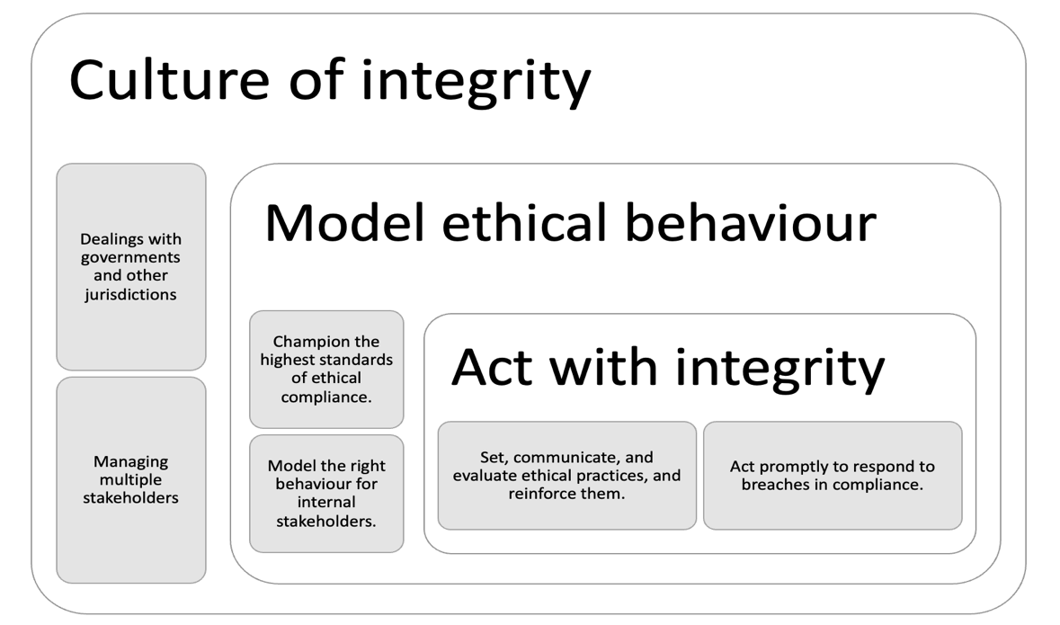

As figure 2 depicts, a PD demonstrating integrity must consider multiple stakeholder interests and mineral exploration regulations that allow KML to stay legally and ethically compliant when gaining permits or conducting exploration activities. This includes working with the Māori and governing bodies and laws that include but are not limited to The Crown Minerals Act (1991). The act guides policies around mineral exploration on land owned by the Crown or iwi. The PD will also need to work with regulators such as NZPAM, the Hawke's Bay Regional Council, the Department of Conservation (DoC), Land Information New Zealand (LINZ), and the Environmental Protection Authority (EPA) to define how the project progresses in the permit stage.

A PD demonstrating this capability would consult with Hawkes Bay's local iwi landowners and hapū early in the project lifecycle (NZPAM, n.d.) to inform them of any impact of exploration activities on the land and iwi lifestyle, as well as KML’s safeguards and compensations under the Crown Minerals Act (1991) that will cover the land and its owners. This practice demonstrates respect for the land's indigenous people, allowing iwi to participate in decision-making early in the process and allowing KML to gain its social licence to operate.

### 2.2. Capability 2: Business enablers: Project Management (PM)

According to Gandhi & Sarkar (2016), mineral exploration can include basic prospecting like panning for gold. However, operations can get more complex based on the technology, data gathering and interpretation methods. Given the varying complexity, uniqueness, tasks and risks that come with a project like KML’s, they can benefit from hiring a PD with Project Management (PM) experience from a PM organisation like IPMA, APM, PMI, or AIPM, according to Worley Parsons’ (2023) job posting for a PD for a global feasibility study.

In Worley Parson's PD job requirements (2023), a fundamental expectation from their PD is to design, organise, test, and ensure the function of the project team, making changes as necessary for the project's success. This can result in clear staff responsibilities that allow for efficient delegation of tasks. For example, the Assessment of Environmental Effects (2011) for mineral exploration and prospecting under Section 59 of the Crown Minerals Act (1991) requires permit applications to be completed by someone familiar with all aspects of the area in question, such as a technical consultant. The PD must consider the right people for responsibilities, including variables like a local guide who can, for example, inform their proximity to Māori sacred sites or National Parks to abide by Treaty legislation.

The NSWPSC (2021) capability framework’s project management guidelines are built into the Regional NSW JD for an exploration assessment manager with nine direct reports (2021). They can benefit KML’s safe and sustainable functioning through the project lifecycle. This JD was compared to KML’s project needs. Hiring a PD at an advanced level of PM capability is essential for KML to ensure that all its requirements for operating efficiently through the project lifecycle are met. This framework, as shown in figure 3, allows KML to meet regulatory standards and design its multiple-stakeholder partnership plan early in the exploration process that factors in clear project proposals, with cost and resource estimates, risk assessments, mitigation plans, rehabilitation plans, key performance areas and measures to monitor the progress of project milestones against goals so that necessary actions can be taken for process improvements (NSWPSC, 2021).

*Figure 3:* Capability - Project Management (Source: NSWPSC, 2021*)*

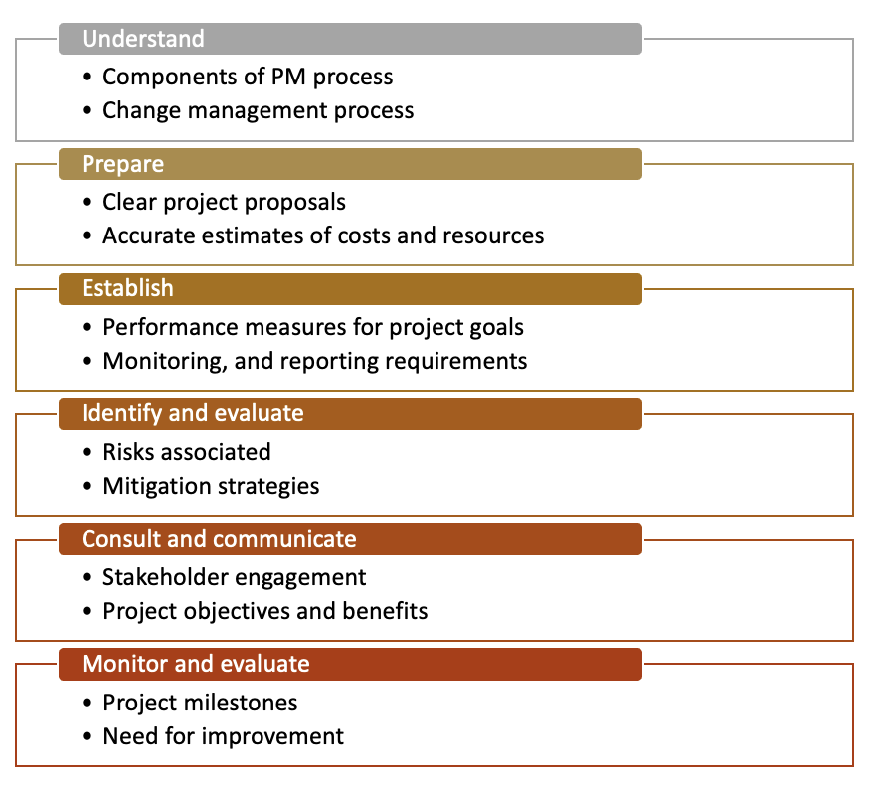

KML's adoption of this capability can ensure their PD can manage, monitor and control the project's processes and deliverables, manage the various stakeholder expectations, and stay proactively prepared for risks and change management opportunities that may arise in the future.

## 3. Maori values as an integral part of KML’s project success

KML's mineral exploration project is in the Hawke's Bay region of New Zealand. The land here is primarily owned by the Māori, the early Polynesian immigrants recognised as the indigenous people of Aotearoa, New Zealand (Mika & O'Sullivan, 2014). According to the Ministry of Māori Development, Te Puni Kōkiri (TPK, 2022), and New Zealand's signing of the United Nations Declaration on the Rights of Indigenous Peoples (UNDRIP, 2007), gaining Indigenous peoples' 'free prior and informed consent' (FPIC) is essential from an exploration operative's perspective.

Māori apply indigenous worldviews in their decision-making, which is essential for KML to understand. The Māori take a holistic approach to the relationships between people and the planet. They are guided by moderation, interdependence and inter-generational equity as opposed to the western worldview of intergenerational legacy (Irihangi, 2022). These principles can be seen in the three principles of partnership, participation, and protection in The Treaty of Waitangi (1840), which support the Māori Crown relationship (Careerforce, 2017).

Aligning to the three principles of the Treaty and understanding Māori values will allow KML to apply an indigenous worldview lens. This will enable proper communication and engagement when KML involves iwi in their project management process. For example, co-designing a maintenance and rehabilitation solution with iwi and hapū guidance or leveraging the NZPAM (2014) guide to engaging with Māori early in the process can help KML recognise gaps and opportunities they may otherwise miss in their project plan.

Hence, considering Māori principles and values allows the iwi to see KML's commitment to protecting the land and its generational owners from harm. Three Māori values: kaitiakitanga, whakarite mana, and whanaungatanga, were picked from the analysis of the Careerforce (2017) learning guide of Māori operating principles and values to aid KML's stakeholder engagement for the project.

### 3.1 Māori Value 1: Kaitiakitanga

### 

According to Ruckstuhl et al. (2014), kaitiakitanga aims to protect the Māori and pass the environment in its current or better than its current state to future generations.  KML's exploration could involve aerial or seismic surveys and data gathering from searches and assessments for mineral availability. However, it can also include intensive surface sampling, drilling core samples, trenching, and bulk sampling studies (NZPAM, n.d.).

Hence, adopting an operational document like the New Zealand (DoC, n.d.) Environmental Effect Assessment for Mineral Exploration and Prospecting can be beneficial to KML. The document considers many aspects like the flora, fauna and habitat assessments, archaeological and historical sites, and scenic landscape qualities while allowing an exploration company to share their proposal with likely adverse effects, safeguards and mitigation plans to avoid such effects. The detailedness of the document will enable KML to inform all stakeholders, including the whānau and the iwi, about how exploration and digital mapping, including rehabilitation, will take place, thereby considering kaitiakitanga.

### 3.2 Māori Value 2: Whakarite mana

### 

Whakarite mana aims at honouring contracts (whakarite) for the good of the community and the environment. Rolleston, T. (2021) brings to attention the Mana Ahuriri deed of settlement recognising seven hapū of Ahuriri (Hawke's Bay) who felt the Crown breached the Te Tiriti o Waitangi, leaving their hapū landless. In 2013, the Crown apologised and made settlements, including amends to recognise sites of historical, cultural, and traditional significance to the Ahuriri hapū. The Crown also acknowledged the hapū as guardians, enabling them to preserve their statutory committee's environmental, social, spiritual, historical, and economic values for future generations.

Upholding the Treaty of Waitangi is important to the government, and KML should be aware of this as the government is their customer and the Crown regulator. For KML, it is essential to keep iwi sentiments in mind when approaching them for permits keeping the context shared above in mind. The right person at KML needs to be speaking with the right iwi group representative since the region has reached a Treaty settlement (NZPAM, n.d.) This will ensure that KML is talking to the right decision-makers assigned to deal with issues such as the permitting process.

Honouring contracts with the local committee is essential for KML to carry out effective operations without disputes that can be managed. Regular meetings with every stakeholder, including the iwi community representatives, can achieve this. KML will also need to share documentation and project updates that ensure transparency for all. The guide to engaging with Māori (NZPAM, 2014) will help KML define meeting objectives and outcomes. It will also help them identify risks and share mitigation plans with transparency through meetings, records, and correspondence. KML holds the Treaty, the environment, and community interests at heart through these practices, building the potential for long-term partnerships.

### 

### 3.3 Māori Value 3: Whanaungatanga

Whanaungatanga is a central concept in literature around collective morality and Māori leadership (Ruwhiu & Elkin, 2016). It also refers to whānau (family belonging) and the depth of these relationships (Roche, 2019), according to Ruckstuhl et al. (2013), who found whanaungatanga central to resource management concerning social well-being. The value aims for decision-making for the collective good of all in the community, not just some individuals.

Hence KML needs to consider that decisions around permits may take time, so factoring in enough time early in the process (NZPAM, n.d.), along with value-based proposals and outcomes linked to the iwi, can help KML present the benefit they will add to the collective community more effectively. This could include compensation and employment opportunities for non-technical tasks that the iwi have the skills for, like site guidance, driving, transporting, and helping KML rehabilitate the land efficiently. It could also include presenting the Environmental Effect Assessment for Mineral Exploration document (DoC, n.d.) early in the project lifecycle to give the committee representatives enough time to make decisions that benefit the iwi and KML's project.

## 4. CSR issues KML should consider in their risk management plans

Corporate Social Responsibility (CSR) refers to a business's contributions to society demonstrated through its self-regulating environmental, ethical, and economic practices. (Stobierski, 2021). For a mineral exploration company, this could mean minimising the social and ecological negative impact caused by their explorations, considering the local people, their livelihoods and the environment (Eerola, 2017). For KML, using a CSR guide like the one created by the International Organization for Standardization, ISO2600:2010 (ISO, 2021), as seen in figure 4, can guide the development of specific social responsibility areas necessary for the Hawke’s Bay project to have successful outcomes. Doing this will guide KML’s CSR strategy and reporting, building trust and long-term partnerships with investors, communities and various stakeholders.

*Figure 4:* ISO 26000:2010 (Source: ISO, 2021*)*

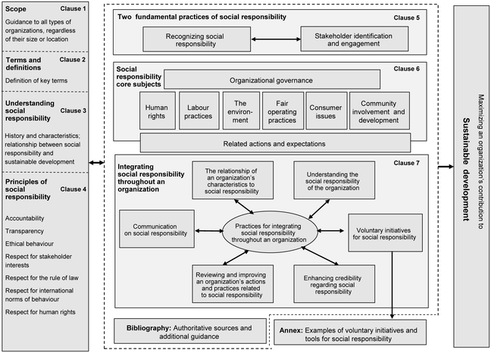

From comparing KML’s project goals to the environment they will operate in, the diverse stakeholders they will engage with, local laws and pre-empting CSR issues that could arise, there were two issues selected for KML to consider as critical areas of focus in the project: stakeholder engagement and employee safety. Stakeholder engagement was also a central CSR area identified in a Finnish mineral exploration investigation report for mineral exploration companies to proactively address and gain a social licence to operate (SLO) which is essential to KML as they will be engaging with local landowners for land access (Eerola (2017). In addition, Safety issues are given prime importance in mineral exploration companies like RSC (n.d.) and SRK (n.d.) to ensure project members operate through safe protocols reducing the risk of harm to themselves and others.

### 4.1 CSR issue 1: Stakeholder engagement

The Minister of Energy and Resources, Dr Woods (2019), in the minerals and petroleum resource strategy for Aotearoa New Zealand: 2019–2029, stated the importance of responsible mineral exploration that respects the environment, cultural interests of Māori and the expectations of local communities, further stating that this can be achieved if the government, Treaty partners, community and mineral industry work together towards sustainability. For this to happen, KML must have a robust stakeholder engagement plan so everyone is informed about and on board with KML’s sustainable operational strategy for the exploration project.

Stakeholders like the government as the Crown mineral regulators, which include the DoC, NZPAM, and EPA, will have to be informed about KML’s Environmental Effect Assessment for Mineral Exploration (DoC, n.d.), which outlines their proposal with likely adverse effects, safeguards and mitigation plans to avoid such effects.

The other stakeholders this CSR area considers are the whānau and the iwi, who need to be consulted on matters relating to exploration and digital mapping on their land, including rehabilitation measures, thereby taking kaitiakitanga and whanaungatanga into consideration. If the Māori hapū do not know much about KML’s operations and intentions, and if the permit application comes as a surprise, it may delay exploration activities.

Erola (2017) suggests that stakeholder engagement is not a one-off activity, as demonstrated in figure 5 of the multi-stage integrated model. It is advisable to connect with community representatives in advance to establish a good relationship and earn a local social license to operate. Figure 5 shares how engagement progresses through the permit phase, including a preparation stage that orients stakeholders to what to expect, a reconnaissance stage that helps KML build personal contacts with stakeholders, a prospecting stage that allows them to clarify all stakeholder expectations during general meetings, and a claim stage where they work with multiple stakeholders, gaining collaborative support.

After the permit process, KML should continue regular meetings with the iwi and the investors so they are constantly kept informed about the progress of the project and deviations, if any, to avoid disputes or stalling of work. This will ensure the project progresses towards closure within the 9-12 month deadline.

*Figure 5:* CSR: Stakeholder Engagement (Source: Eerola, 2017*)*

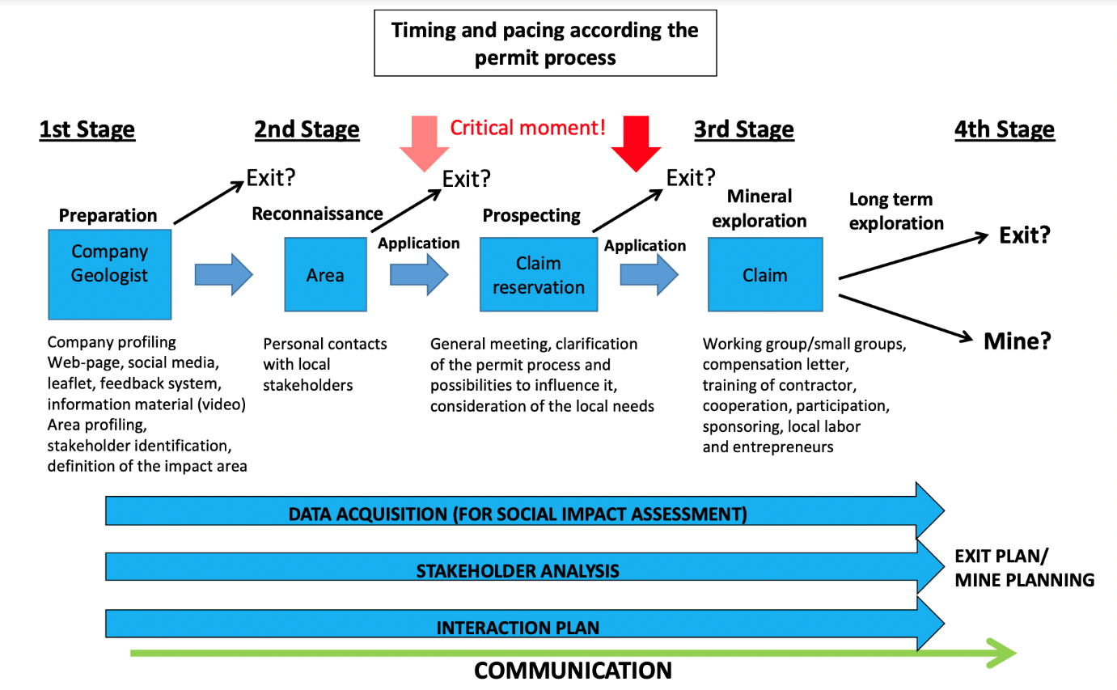

### CSR Issue 2: Employee Safety

KML must consider their exploration methods and the hazards they may pose to KML’s workers. They need to mitigate this occurrence proactively. The government of Western Australia (2022) created a guide for exploration hazards that can be avoided. For example, suppose KML has a drilling activity involved in its exploration process; it may need to factor in activities like camp and work-site preparation, drill pad preparation, and downhole surveying. Some hazards in the guide that may apply to KML’s operations include manual tasks, fatigue, mental well-being, use of electricity, chemicals, and rotating machinery, to name a few. Some other challenges that KML may need to solve are environmental conditions during exploration and access to the exploration area so heavy equipment can be transported without injury. The guide also includes safety protocols to assess risks before exploration starts, like surveying sites to mitigate hazardous conditions, ensuring hygienic areas for food, and using safety and warning signs in places that are clear and legible to all workers.

New Zealand’s health and safety regulator, WorkSafe (2013), is a stand-alone Crown Entity focused on workplace health and safety with a specialist High Hazards Unit (HHU) that regulates mineral and mining operations. KML may need to factor in WorkSafe protocols as listed in their health and safety management system to ensure workers are kept safe through a Principal Hazard Management Plan that WorkSafe approves.

It is also recommended that KML includes the required instruction, training and governance methods (SRK, n.d.) to ensure staff operate tasks safely. Some examples include vehicle travel safety, first aid, emergency evacuation procedures and situational awareness training.

Adhering to these recommendations will allow KML to integrate CSR requirements in their health and safety management system (RSC, n.d.) to meet all health and safety requirements, thereby avoiding foreseeable disasters.

### 5. Conclusions and Recommendations

In conclusion, the KML Board of Directors have a winning plan if they hire a PD who acts with integrity and is certified in PM. This will give KML a leader with the Project Management capability and integrity to handle complexities, unique tasks, risks, and multiple stakeholders efficiently, adhering to regulatory standards and progressing project goals. The iwi are not conventional stakeholders, given their historical rights of governance, and legal protections, so embedding the three Māori values, kaitiakitanga, whakarite mana, and whanaungatanga, into KML’s operating principles will allow for an indigenous lens in stakeholder engagement. It helps KML honour contracts and builds trust with Māori around the Treaty of Waitangi’s principles of partnership, participation and protection. Finally, ensuring strong knowledge of mineral exploration regulations, rights, and responsible exploration will allow KML to mitigate CSR issues and risks linked to stakeholder engagement and safety. This will allow for successful project closure, meeting all stakeholder expectations, and possibly creating future partnership opportunities for KML’s growth in their market.

### 6. References

Audit. N. Z. (n.d.). Audit New Zealand. Probity and integrity. https://www.auditnz.parliament.nz/resources/probity-and-integrity

Careerforce. (2017). Careerforce Community Support Services ITO Ltd. Learning Guide: *Māori operating principles and values*. Learning guide issue 1.1. p8-12.

DoC. (n.d.). New Zealand Department of conservation. *Mining. Environmental effect for mineral exploration & prospecting.* https://www.doc.govt.nz/get-involved/apply-for-permits/mining/

Energy & Mining. (2023). Government of South Australia Energy and Mining. Mineral exploration code of conduct. https://www.energymining.sa.gov.au/industry/minerals-and-mining/exploration/mineral-exploration-code-of-conduct

Energy & Mining. (2022).  Government of South Australia Energy and Mining. What is a PEPR?  https://www.energymining.sa.gov.au/industry/minerals-and-mining/mining/major-projects-and-mining-activities/major-operating-and-approved-mines/hillside-project/frequently_asked_questions2/what_is_a_pepr

Eerola, T. (2017). Academia Edu. Corporate social responsibility in mineral exploration – *The importance of communication and stakeholder engagement in earning and maintaining the social license to operate the Geological Survey of Finland*.   https://www.academia.edu/35639524/Corporate_social_responsibility_in_mineral_exploration_The_importance_of_communication_and_stakeholder_engagement_in_earning_and_maintaining_the_social_license_to_operate_Geological_Survey_of_Finland

Gandhi, S. M., & Sarkar, B. (2016). Science Direct. Geological Exploration. Elsevier EBooks, 159–198. <https://doi.org/10.1016/b978-0-12-805329-4.00014-4>

Government. N.Z. (2011). AEE. Environmental effect assessment for mineral exploration and prospecting. https://www.doc.govt.nz/globalassets/documents/about-doc/concessions-and-permits/mineral-exploration/eea-mineral-exploration-and-prospecting.pdf

Government. N.Z. (2022). Crown Minerals Act 1991. Public Act Contents – New Zealand Legislation. No 70. https://www.legislation.govt.nz/act/public/1991/0070/latest/DLM242536.html

WHS. (n.d.). Government of Western Australia. Department of Mines, Industry Regulation and Safety. *Guidance about exploration hazards.* https://www.dmp.wa.gov.au/Safety/Guidance-about-exploration-6781.aspx

Jobs4Mining. (2016). Jobs4Mining. Project Director. Mining - EPCM PD. https://www.jobs4mining.com/jobs/4805895/project-director-mining-epcm.asp#:~:text=Ensures

Ihirangi. (2022). Ministry for the Environment. Government of New Zealand. *Exploring an indigenous worldview framework for the national climate change adaptation plan.* https://environment.govt.nz/publications/exploring-an-indigenous-worldview-framework-for-the-national-climate-change-adaptation-plan/

.ISO  ( 2021), ISO. ISO 26000:2010. *Guidance on social responsibility*. https://www.iso.org/obp/ui/#iso:std:iso:26000:ed-1:v1:en

NSWPSC. (2021). NSW Public Service Commission. The Capability Framework https://www.psc.nsw.gov.au/workforce-management/capability-framework/the-capability-framework

NZPAM. (2014). NZPAM. New Zealand Petroleum and Minerals. *Best practice guidelines for engaging with Māori.* Retrieved 28 March 2023, from https://www.nzpam.govt.nz/assets/Uploads/doing-business/engagement-with-maori-guidelines.pdf

NZPAM. (2021). New Zealand Petroleum and Minerals. *Value and benefits to New Zealand.* Retrieved 28 March 2023, from https://www.nzpam.govt.nz/nz-industry/value-benefits/

OAG. (2023). Office of the Auditor-General New Zealand. Integrity and how to support it. https://oag.parliament.nz/good-practice/integrity

Regional NSW. (2021). Regional NSW. Role description. Manager Mining and Exploration Assessment. https://files.jobs.nsw.gov.au/o5gkef

RSC. (n.d.) RSC Mining & Mineral Exploration. Governance. *Code of conduct*. https://www.rscmme.com/governance

Rolleston, T. (2021). RNZ. Treaty settlement legislation for Hawke’s Bay hapū passes final reading.  https://www.rnz.co.nz/news/te-manu-korihi/457431/treaty-settlement-legislation-for-hawke-s-bay-hapu-passes-final-reading

Ruwhiu, D., & Elkin, G. (2016). Converging pathways of contemporary leadership: In the footsteps of Māori and servant leadership. Leadership, 12(3), 308–323. https://doi.org/10.1177/1742715015626326

Ruckstuhl, K., Carter, L., Easterbrook, L., Gorman, A. R., Rae, H., Ruru, J., … Turner, R. (2013). Maori and Mining. Te Poutama Maori, University of Otago, The Maori and Mining Research Team. Retrieved from http://hdl.handle.net/10523/4362

SRK. (n.d.). SRK Consulting. Mining Exploration Operations | *Exploration operation health and safety*.  <https://www.srk.com/en/services/exploration-operation-health-and-safety>

Stobierski, T. (2021). HBR Business Insights Blog. Types of Corporate Social Responsibility to Be Aware Of. https://online.hbs.edu/blog/post/types-of-corporate-social-responsibility

Sykes, J. P., & Trench, A. (2017). Reseach Gate. Culture, leadership and other “soft skills” in minerals exploration: the emperor or the emperor’s new clothes? <https://doi.org/10.13140/RG.2.2.11291.98087>

TPK. (2022). Te Puni Kōkiri. Te ao Māori. UN Declaration on the Rights of Indigenous Peoples.  https://www.tpk.govt.nz/en/a-matou-whakaarotau/te-ao-maori/un-declaration-on-the-rights-of-indigenous-peoples#:~:text=New%20Zealand%20is%20committed%20to,addressing%20indigenous%20rights%20and%20interests.

Woods, M. (2019). New Zealand Ministry of business innovation and employment. Responsibly delivering value. *A Minerals and Petroleum Resource Strategy for Aotearoa New Zealand: 2019–2029.* https://www.mbie.govt.nz/dmsdocument/7148-responsibly-delivering-value-a-minerals-and-petroleum-strategy-for-aotearoa-new-zealand-2019-2029

Worksafe. (n.d.). Worksafe NZ. Mining. *A hazard management system for mining operations.* https://www.worksafe.govt.nz/topic-and-industry/extractives/mining/a-hazard-management-system-for-mining-operations

Worley. (2023). Worley Parsons. Project Director, *Mining, Minerals, Metals*. https://worleyparsons.taleo.net/careersection/ext/jobdetail.ftl?lang=en&job=ARI0009

### 

### 7. Appendix

The illustrations in figures 6 and 7 include examples of boulder sampling and drilling survey machinery that KML may use for their exploration. If they do, they must consider safety protocols and land rehabilitation needs to ensure responsible exploration protocols are adhered to in accordance with WorkSafe and the Crown and Treaty regulations.

*Figure 6:* Boulder sampling using a hammer (Source: Eerola, 2017).

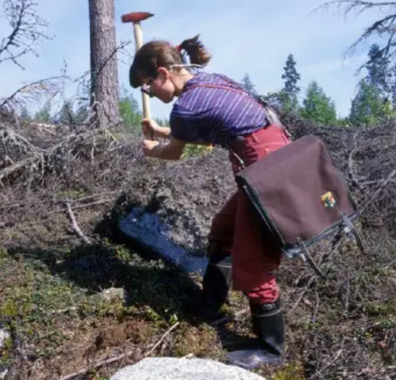

*Figure 7:* Drilling survey machinery for gold exploration (Source: Eerola, 2017).

